JOHANNES KEPLER
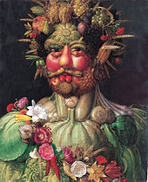
ARCIMBOLDO
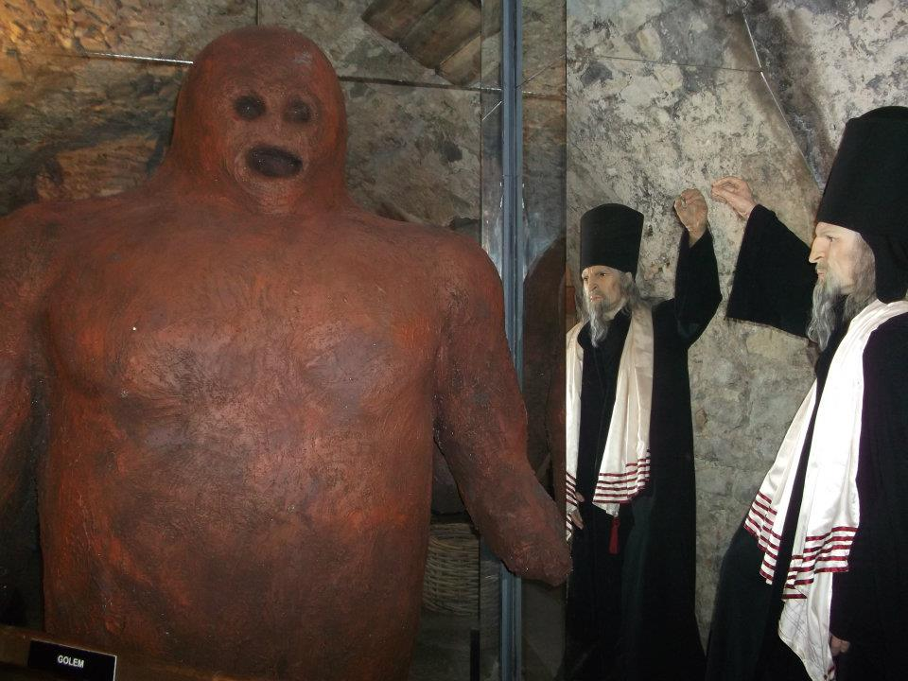
RABI LÖW AND GOLEM
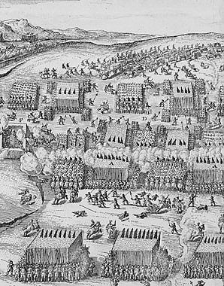
BATTLE OF WHITE MOUNTAIN – 30 YEARS WAR
GADGETS AND MACHINERY OF RUDOLFIAN ERA

